HEALTHY EATING PYRAMID
An important guide to help people follow a healthy diet

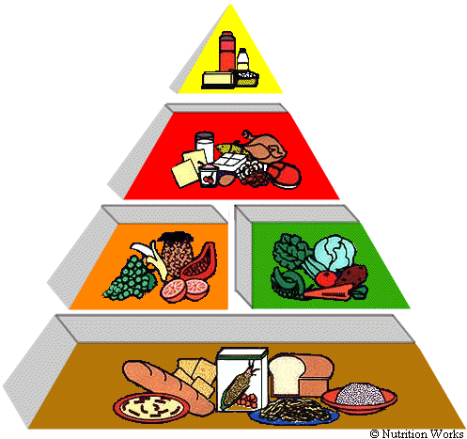
EXERCISE 1: READ THE TEXT BELOW, THEN WRITE THE NAME OF THE FOODS NEXT TO THE PYRAMID
The small tip of the Pyramid shows fats, oils, sugar and salt. These are foods such as cooking oils, butter, margarine, sugars, sweet desserts, seasonings and sauces. These foods provide calories and little else nutritionally. Most people should use them rarely.
On the next level of the Healthy Diet Pyramid are foods that come mostly from animals: Meat and Alternatives like beef, lamb, mutton, pork, poultry, fish, beans, eggs, milk, yogurt, cheese; nuts and seeds. These foods are for protein, calcium, iron, and zinc.
The third level includes foods that come from plants - Vegetables and Fruits. Most people need to eat more of these foods for the vitamins, minerals, and fibre they supply.
At the base of the Healthy Diet Pyramid are Rice and Alternatives like noodles, bread, cereals and pasta - all foods from grains. Your daily meals should include large number of servings of these foods each day.
The Food Groups
RICE AND ALTERNATIVES GROUP | 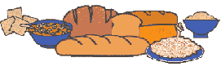
Why are Rice and Alternatives foods important?
These foods provide complex carbohydrates, which are important sources of energy, especially in low-fat diets. They also provide vitamins, minerals, and fibre. The Healthy Diet Pyramid suggests 5 to 7 servings of these foods a day.
Aren't starchy foods fattening?
No. It's what you add to these foods or cook with them that adds most of the calories. For example: margarine or butter on bread, oil in frying rice.
Here are some tips:
»To get the fibre you need, choose several servings a day of foods made from whole grains, such as whole wheat bread and brown rice.
»Choose most often foods that are made with little fat or sugars. These include plain rice, bread, noodles and pasta.
»Baked goods made from flour, such as cakes, cookies and croissants, count as part of this food group, but they are high in fat and sugars.
»Reduce the fat and sugars you add as seasonings or toppings.
FRUIT GROUP | 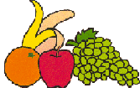
Why are fruits important?
Fruits and pure fruit juices provide important amounts of vitamins A and C and potassium. They are low in fat and sodium. The Healthy Diet Pyramid suggests 2 servings of fruits a day.
Here are some tips:
»Choose fresh fruits, fruit juices and dried fruit. Avoid fruit canned in syrups and sweetened fruit juices unless you need the extra calories.
»Eat whole fruits more often - they are higher in fibre than fruit juices.
»Have citrus and yellow-orange flesh fruits such as oranges, grapefruit, papaya, and mango regularly. They are rich in vitamin C.
»Count only 100 percent fruit juice as fruit. Most fruit drinks contain only a little juice and lots of added sugars. Orange sodas and Fanta do not count as fruit juice.
VEGETABLES GROUP | 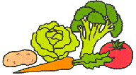
Why are vegetables important?
Vegetables provide vitamins, such as vitamins A and C, and minerals, such as iron and magnesium. They are naturally low in fat and also provide fibre. The Food Guide Pyramid suggests 2 servings of vegetables a day.
Here are some tips:
»Different types of vegetables provide different nutrients. For variety eat dark-green leafy vegetables (spinach), deep-yellow vegetables (carrots, turnips), starchy vegetables (potatoes, corn, peas), legumes (soya beans, lentils, peas), other vegetables (lettuce, tomatoes, onions)
»Include dark-green leafy vegetables and legumes several times a week - they are especially good sources of vitamins and minerals. Legumes also provide protein and can be used instead of meat.
»Reduce the fat you add to vegetables after or during cooking. Added toppings, such as butter, mayonnaise, and salad dressing, count as fat.
MEATS & ALTERNATIVES GROUP | 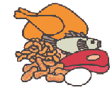
Why are Meat and Alternatives important?
Meat, poultry, and fish supply protein, B vitamins, iron and zinc. The other foods in this group - dry beans, eggs, and nuts - are similar to meat in providing protein and most vitamins and minerals. The Healthy Diet Pyramid suggests 2 to 3 servings each day of foods from this group.
Here are some tips:
» Choose lean meat, poultry without skin, fish, and beans and peas often. They are the lowest fat choices.
» Prepare meats in low fat ways:
- Trim away all the fat you can see.
- Broil, roast, or stew these foods, instead of frying them.
» Reduce egg yolk; it's high in cholesterol. Use only one yolk per person in egg dishes. Make larger portions by adding extra egg whites.
» Nuts and seeds are high in fat, so eat them in moderation.

Think of water and exercise as food groups in your diet.
Water. Water helps free our systems from waste products and toxins, yet many people go through life dehydrated—causing tiredness, low energy, and headaches. It’s common to mistake thirst for hunger, so staying well hydrated will also help you eat less and make healthier food choices.
Exercise. Find something active that you like to do and add it to your daily routine. The benefits of lifelong exercise are abundant and regular exercise may even motivate you to make healthy food choices.
EXERCISE 2: COMPLETE THE FOOD TABLE
 | Rice and alternatives | Fruit | Vegetables | Meat and similar
Examples of foods
They provide
N. of servings
Tips

EXERCISE 3: ANSWER THE QUESTIONS
1. Are starchy foods fattening?
2. What are the most fattening foods of the first food group?
3. Is it better to eat fruit or drink fruit juice? Why?
4. Where can you find a lot of vitamin C?
5. Give examples of starchy vegetables
6. What food can legumes replace? Why?
7. Why is water important?
8. Why can water help you to eat healthier?
9. Why is exercise important?

