QUEEN VICTORIA'S LIFE
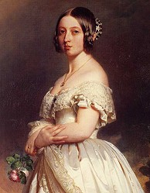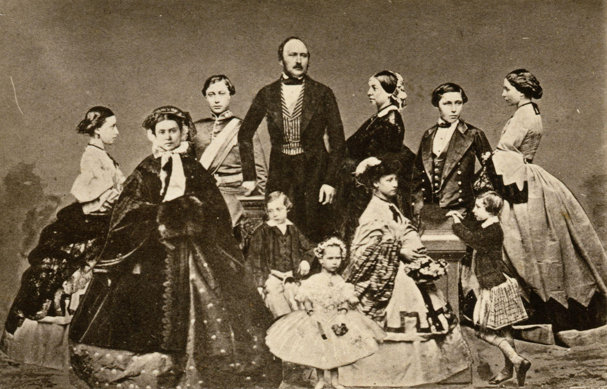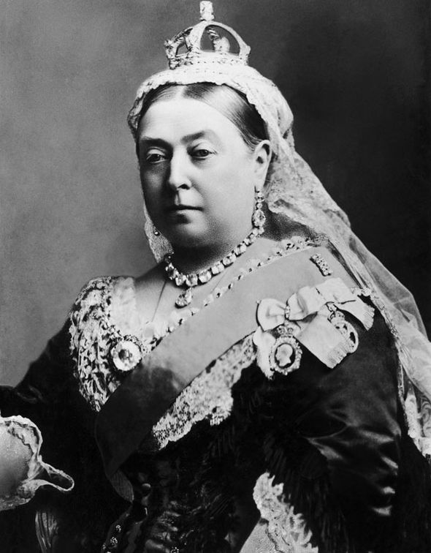
Her reign was the longest of the British history until Queen Elizabeth II broke her record; Victoria became Queen at 18 and she died at 81, so she reigned for 63 years
She married Prince Albert at 21, it was a very happy marriage and they had 9 children. Unfortunately Albert died at 42, Victoria never married again and she wore black clothes until her death to remember her husband.
Her exemplary life and her strict morality made her beloved by the English people, especially by the middle class who shared her moral and religious ideas. She was the symbol of Great Britain in this period that was characterized by strict moral values.

VICTORIAN VALUES
RESPECTABILITY: A respectable Victorian man had a good job, good manners, a beautiful house and servants, a nice family, a good wife who stayed at home taking care of their children and he went to the church regularly. This respectability was usually mixed with hypocrisy because the same respectable men often had hidden vices (they had lovers, they gambled and drank...)
MORALITY: Women had to get married and had children and then they had to stay at home, they couldn't work. Women who had a child without being married were rejected by their families and by the society and they were called "fallen women". Sexuality was strongly repressed and considered something bad and sinful. Also many forms of entertainment were considered dangerous and sinful.
PHILANTHROPY: In this period a lot of poor people lived in the industrial towns in terrible conditions, they had to work 14/16 hours a day, they lived in the so called "slums", suburbs full of overcrowded, squalid and very dirty houses without any service. Diseases such as cholera and tuberculosis were common and the mortality rate among these people was very high. Many of these people became alcoholic or drug-addicted to try to forget their situations. In this period the richer classes (especially the middle class) started considering a duty to improve the condition of the society in general and of the weakest people in particular.
In this period the first modern hospitals were built and a lot of charities were founded to help the poor, the sick, the disabled, the unemployed, the orphans etc. and to redeem prostitutes, drunkards and so on. There were also the so called "ragged schools" that gave poor children a rudimentary education.
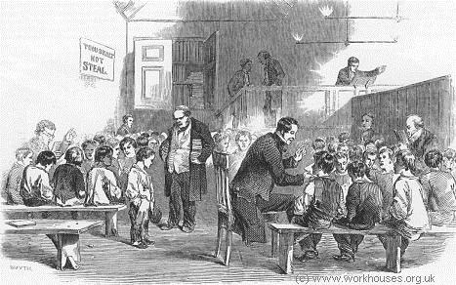
THE WORKHOUSES
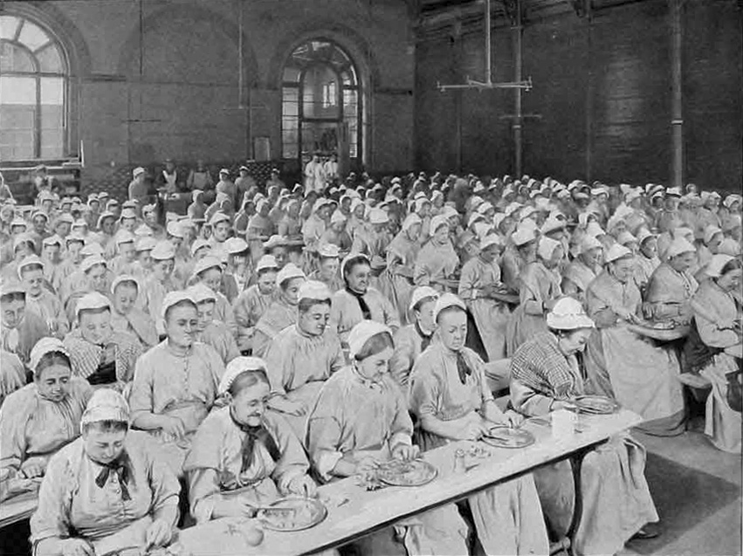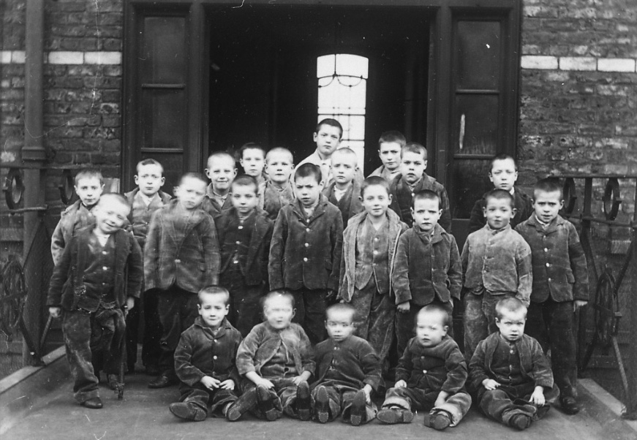
In this period a lot of workhouses were built in the towns, they were run mainly by the church and they gave a home to people who couldn't survive alone (orphans, unemployed, single women...). The conditions in the workhouses were terrible, families were usually separated, everyone had to work for free and rations of food and clothing were poor and small. The workhouses were based on the idea that poverty was a consequence of laziness and that these horrible conditions would convince the people to do anything to leave these places. However the workhouses didn't give any real means for social or economic improvements, for example they didn't teach the children a job or to read and write, they only exploited them.

THE BRITISH EMPIRE
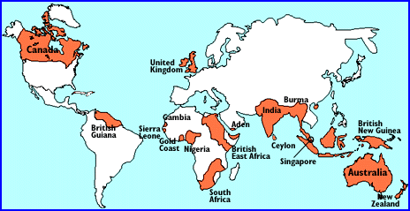
During the Victorian age, Great Britain became a very large and powerful empire that included a lot of countries in Africa, Asia and Oceania. In 1877 Queen Victoria was crowned Empress of India.
Colonialism was a typical phenomenon of this age and it was based on the idea of racial superiority. The British (and the Europeans in general) thought that they were a superior race that was destined by God to lead the others. They were convinced it was even a duty for them (they called it "The white man's burden") to spread their superior way of life, culture, laws and institutions on native peoples all over the world.

THE PROGRESS IN THE VICTORIAN AGE
