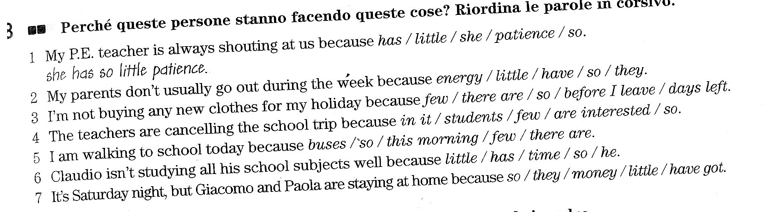

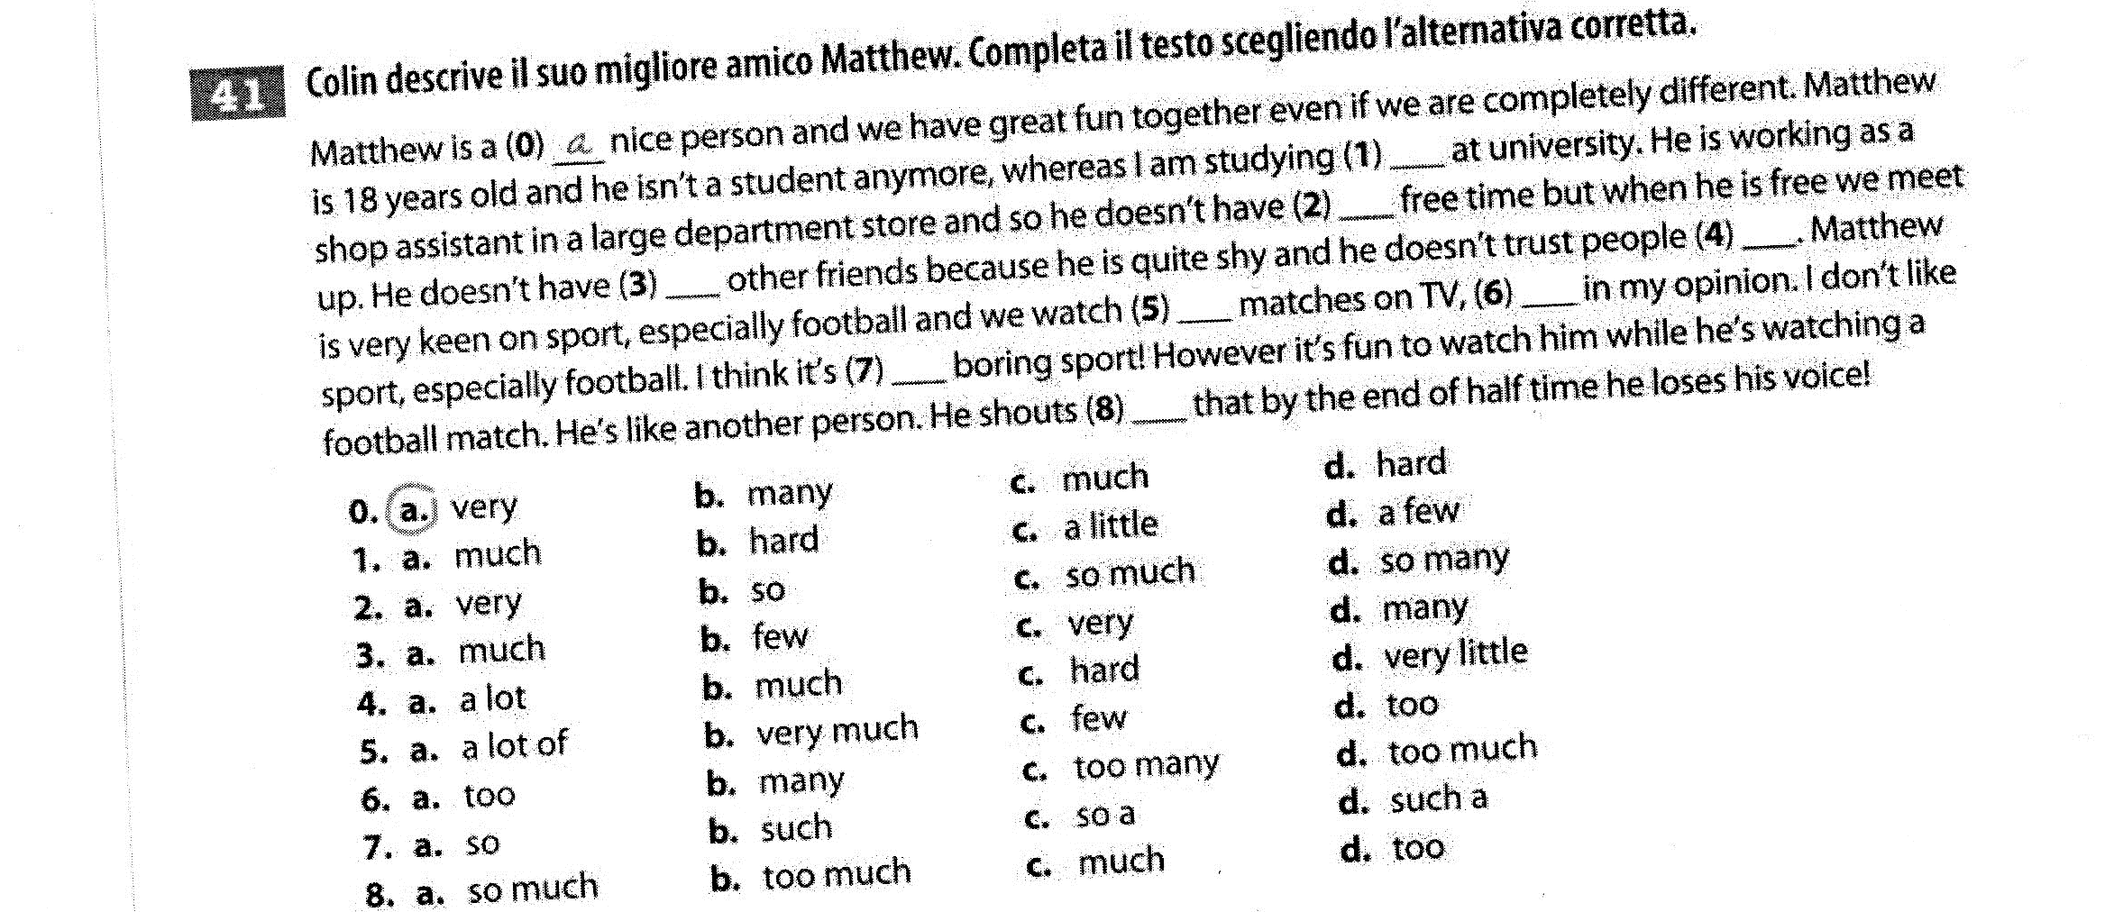
EXERCISE N. 1: Use too much / too many / too to complete the sentences
1. 36 in a class! There are __________ children
2. It's ______________ noisy in here, be quiet!
3. They watch _____________ TV
4. Nobody uses the buses, so there's _____________ traffic
5. He sleeps ____________
6. You go out ____________ often
7. I'm _______________ angry to speak to you
8. Sometimes teachers give ____________ homework
EXERCISE N. 2: Translate
1. Sono troppo preoccupato per dormire
2. C'è troppo rumore, non riesco a studiare
3. E' troppo lontano, non possiamo andare a piedi
4. Ci sono troppe persone in questo cinema
5. Tu mangi troppe caramelle e bevi troppo caffè

EXERCISE N. 3: Use much/many or a lot of . Write all the possibile options
1. There aren’t ....................... portraits of Shakespeare.
2. Don’t be discouraged! ....................... people have failed to run the marathon.
3. How ....................... pictures are you going to buy?
4. If you have ....................... news call me back.
5. Last week there was so ....................... rain that I was not able to go out.
6. Tom drinks ....................... milk – one liter a day.
7. We didn’t take ....................... photographs when we were on holiday.
8. Did you invite ....................... guests?

EXERCISE N. 4 Use few/a few, little or a little.
1. Hurry! We’ve got ....................... time.
2. I saw Tom ....................... days ago.
3. If what you say is true, there is ........................ we can do about it.
4. I can’t let you use much of this perfume. There’s only ....................... in the bottle.
5. This town isn’t very well-known and there isn’t much to see, so ....................... tourists come here.
6. I don’t think Jill would be a good teacher. She’s got ....................... patience with children.
7. “Would you like some more cake?’ – “Yes, please, but only .......................
8. This is not the first time the car has broken down. It has happened ....................... times before.
9. There is a shortage of water because there has been very ....................... rain recently.

EXERCISE N.5: Translate
1. Lei ha sempre tanti compiti di matematica
2. Quanto tempo hai adesso? Non molto, è molto tardi e devo andare a casa
3. Hai visitato molti paesi stranieri? No, solo un po'
4. Maria conosce poche persone e ha pochi amici perché è molto timida
5. Quanti fratelli hai?
6. Mia sorella mi da sempre molti consigli utili
7. Quando esci, compra un po' di latte e un po' di mele
8. Puoi darmi qualche informazione su questa città? Non conosco questa città molto bene, non abito qui

