OSCAR WILDE: THE TRIAL
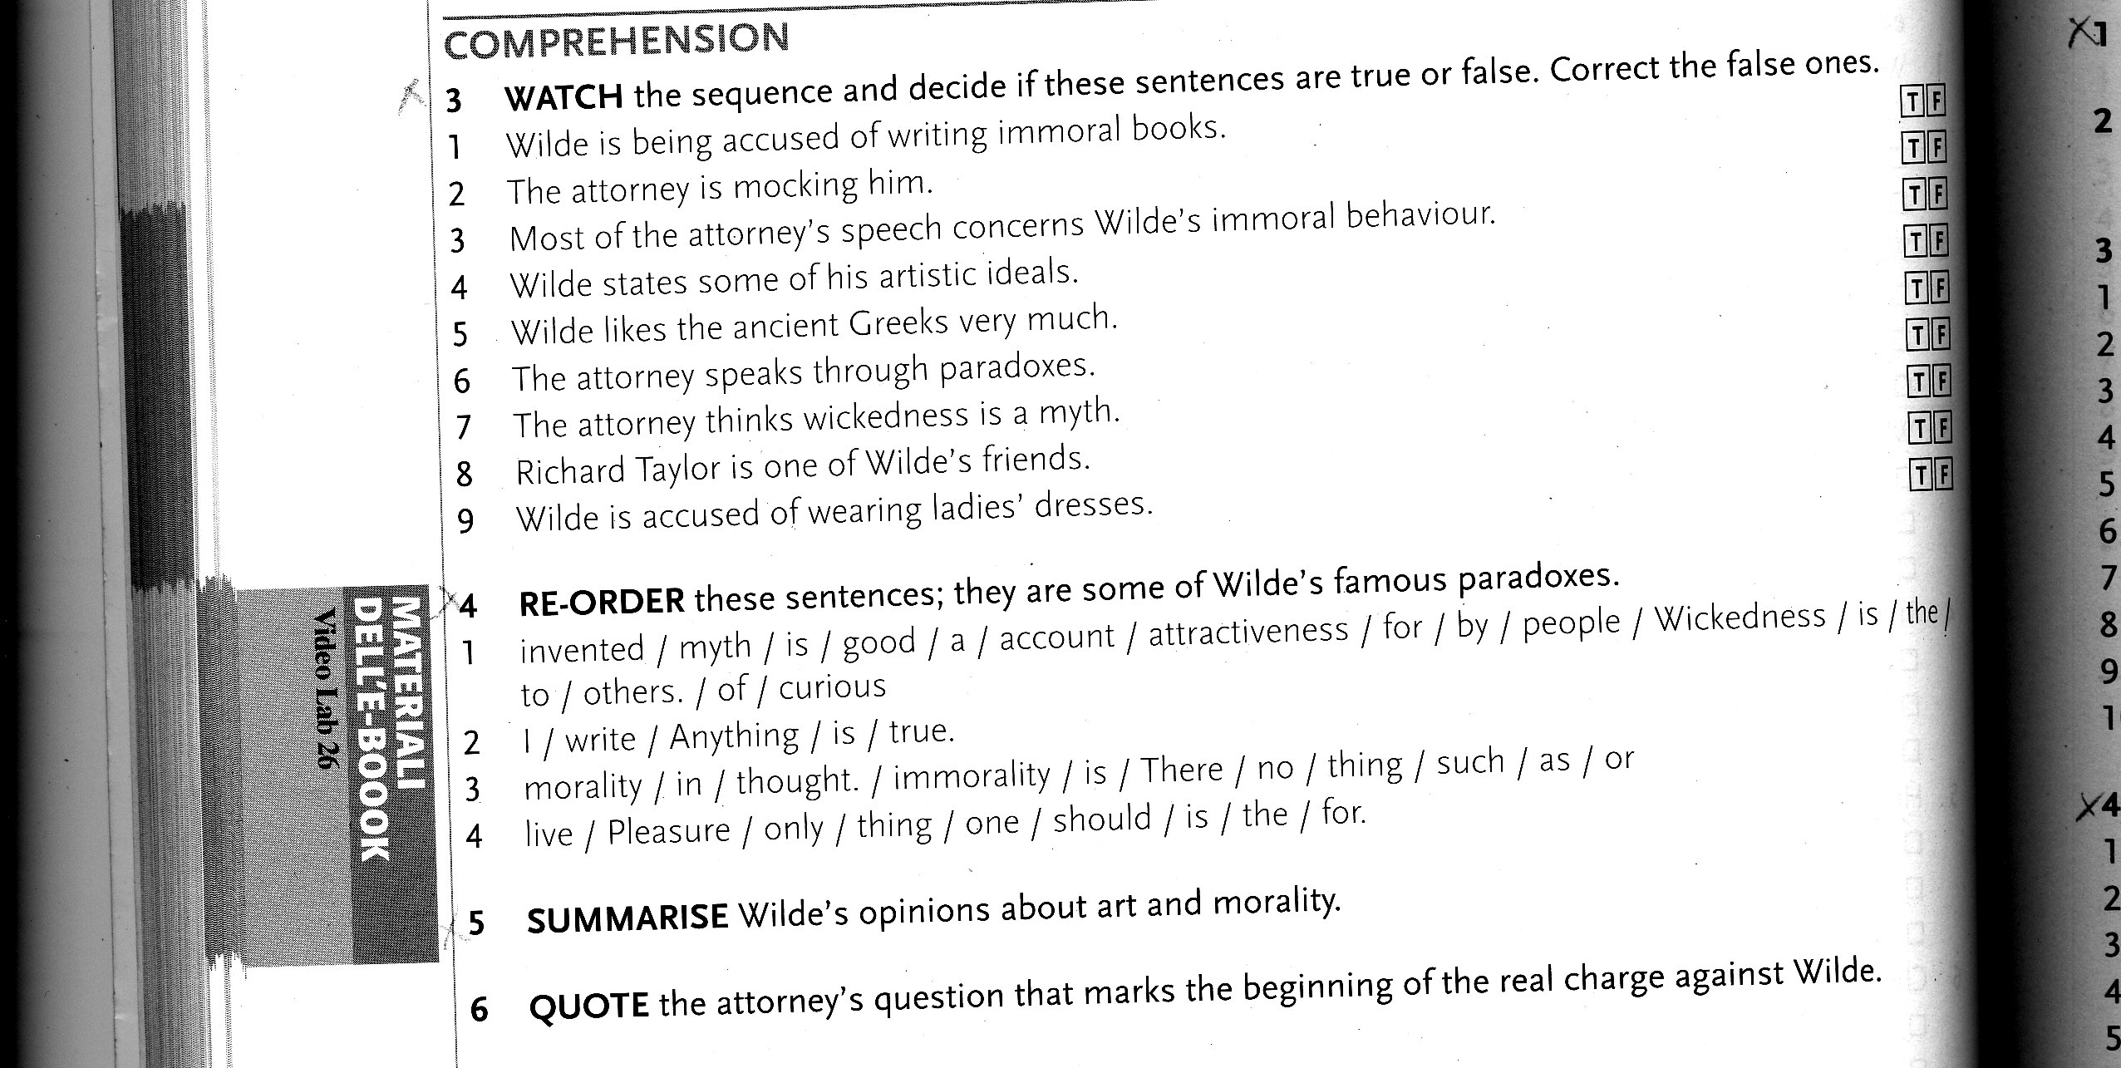
THE PICTURE OF DORIAN GRAY: THE PACT
