QUANTIFIERS: ESERCIZI (1)

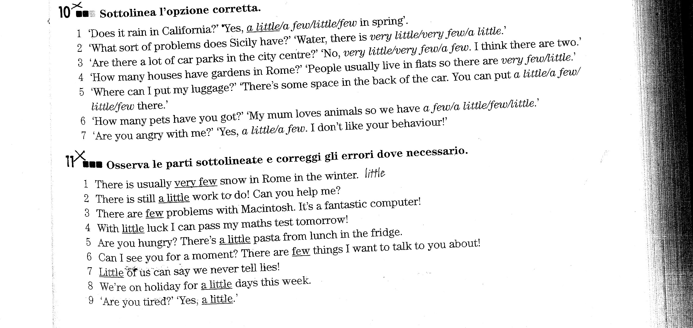
EXERCISE N.1
Complete the sentences with the correct option
1. He gets very / very much hungry when he watches his mum cooking
2. Hey Jane, we've little / a little flour, not enough for the recipe
3. There are few / a few ingredients on this list, are you sure it's ok?
4. There aren't much / many pastries at the bakery today
5. I don't fry very much / very, I prefer grilling food
6. We've got very much / a lot of fruit juice
7. We don't like eating in the canteen very / very much
8. Do your children eat very / very much for breakfast?
9. I like Steve a lot / many, he is very kind
10. I'm sorry I don't have much / many books on tennis
11. Your daughter is a very / much beautiful girl, you are very / much lucky
12. Spring is wonderful, there are much / a lot of flowers everywhere
EXERCISE N. 2
Complete the sentence using VERY, LITTLE, A LITTLE, FEW, A FEW, MUCH, VERY MUCH, MANY
1. That isn't a ___________ nice thing to say to your sister, Steven!
2. Have you got any sugar? Yes, there is _____________ in the bowl
3. Albert doesn't dance _____________, he prefers listening to music
4. There's __________ chance of winning the local lottery, you must be _______ lucky!
5. There are _________ occasions when I get really angry, and this is one of them
6. Can you buy ____________ oranges while you are out?
7. I am __________worried about Vanessa, she really eats ___________ in this period
8. You brother is ___________ annoying, I can't stand him!
9. Help me! I have ____________ baggage
10. You must go to the butcher, there is ____________ beef
11. There aren't _____________ canals in my country
12. This basket is _____________ small
EXERCISE N. 3
Complete the sentences with the correct option
1. There is so much / too many time before the interview, we can wait a few minutes
2. There are so many / so much wonderful cars here, I am amazed!
3. You buy too many / too much presents for people, you are too / too much generous
4. There are so many / so much places I'd like to visit in the world
5. I have so much / so to do for the wedding and so little / so few time to do it all
6. There are so many / too many passengers on the train that I can't find a free seat
7. Excuse me, madam, but your child is so / so many noisy! This is a restaurant after all!
8. You have so much / so many beautiful clothes, lucky you!
EXERCISE N. 4
Translate:
1. Perché stai facendo così tanto rumore (noise)?
2. Ci sono molte lingue antiche in Africa, ma la gente non le parla molto perché sono molto difficili
3. Hai molti parenti? Sì, ne ho molti. Ho così tanti cugini che non riesco a ricordare i loro nomi
4. Se hai poco tempo, puoi preparare questa torta per la festa, è molto facile e veloce
5. Non ci sono molti cigni (swans) nel lago perché oggi fa troppo freddo

