MODALI CHE INDICANO POTERE: ESERCIZI
Exercise 1: completa con could o was/were able to alla forma corretta.

1. When I was young, I run a marathon.
2. I got the job because I start immediately.
3. The weather was sunny, so we eat outside.
4. My grandmother speak three languages.
5. During the weekend we do some gardening.
6. I contact him, last night.
7. When she was young, my aunt run for miles.
8. In those days, we take holidays because we had too much work.
9. We finish all the meal, it was too big.
10. We catch the 7.30 train.

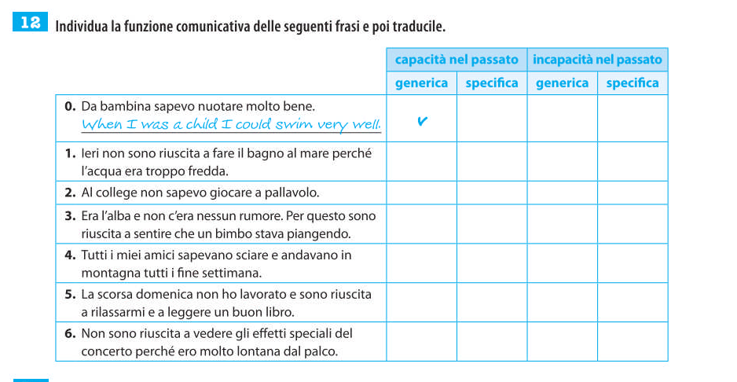

VERBI MODALI PER ESPRIMERE DEDUZIONI
Must esprime __________________
Es. Lui deve essere inglese ______________________
Can't esprime ___________________
Es. Laura è andata in vacanza, non può essere a casa__________________________
Could/May/Might esprimono _________________________
Es. Potrebbero esserci degli errori, controlla! ________________________________

Esercizio n. 2
Inserisci must/can’t/could/may/might
1I'm sure he is here - I can see his car in front of the building.
He be here. I can see his car in front of the building.
2They're coming this week but I don't know which day.
They be coming tomorrow.
3I'm not sure I'm going to pass the exam. I don't feel very confident.
I pass the exam. I don't feel very confident.
4I've bought a lottery ticket. There's a chance I'll become a millionaire!
I become a millionaire!
5I'm sure she doesn't speak French very well - she's only lived in Paris for a few weeks.
She speak French very well. She's only lived in Paris for a few weeks.
6My key's not in my pocket or on my desk so I'm sure it's in the drawer.
My key's not in my pocket or on my desk so it be in the drawer.
7Someone told me that Mark was in Mexico but I saw him yesterday so I'm sure he's not abroad.
Mark be abroad.
8You got the job? That's great. I'm sure you're delighted.
You got the job? That's great. You be delighted.
9They told me to prepare the project by tomorrow but it's almost impossible to do it so fast.
I finish it by tomorrow if I stay at work all night, but I'm not sure.
10I asked them to send the goods as soon as possible; we receive them by the end of the week if the post is fast.

