MODALI CHE INDICANO POTERE: ESERCIZI
Exercise 1: completa con could o was/were able to alla forma corretta.

1. When I was young, I run a marathon.
2. I got the job because I start immediately.
3. The weather was sunny, so we eat outside.
4. My grandmother speak three languages.
5. During the weekend we do some gardening.
6. I contact him, last night.
7. When she was young, my aunt run for miles.
8. In those days, we take holidays because we had too much work.
9. We finish all the meal, it was too big.
10. We catch the 7.30 train.

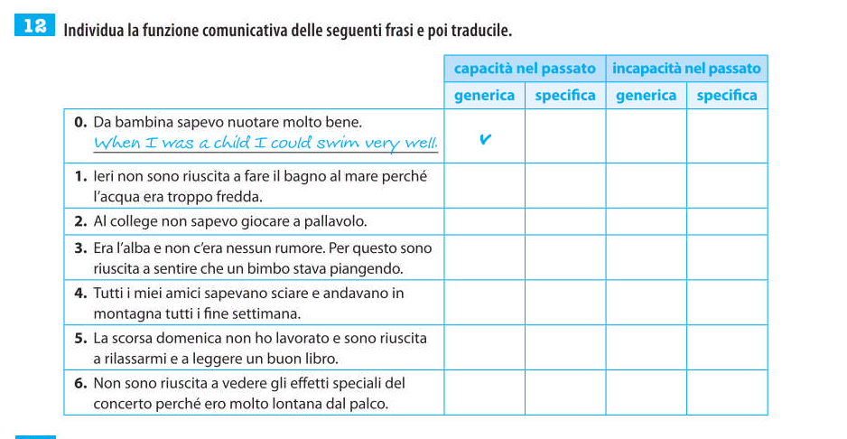
ESERCIZIO N. 2: Complete the sentences using the correct form (affirmative, interrogative or negative) of POTERE (can, could, be able to).

- Maybe the Smiths a new house next year. (build)
- If you try hard, you your examinations next July. (pass)
- When I was five, I . (not/swim)
- Dennis the trumpet since he was 10. (play)
- Luke has passed his driving test, now he a car. (drive)
- I to him on the phone for three hours. (not/speak)
- Alex his homework when his desk is in such a mess. (not/do)
- They were so busy, they me. (not/text)

Esercizio 3: traduci usando MAY o MIGHT (scegliete quello che preferite)
- Jack potrebbe non essere a casa, potrebbe essere in palestra
- Lara potrebbe cambiare scuola oppure potrebbe cercare un lavoro

