**OSCAR WILDE: THE TRIAL**

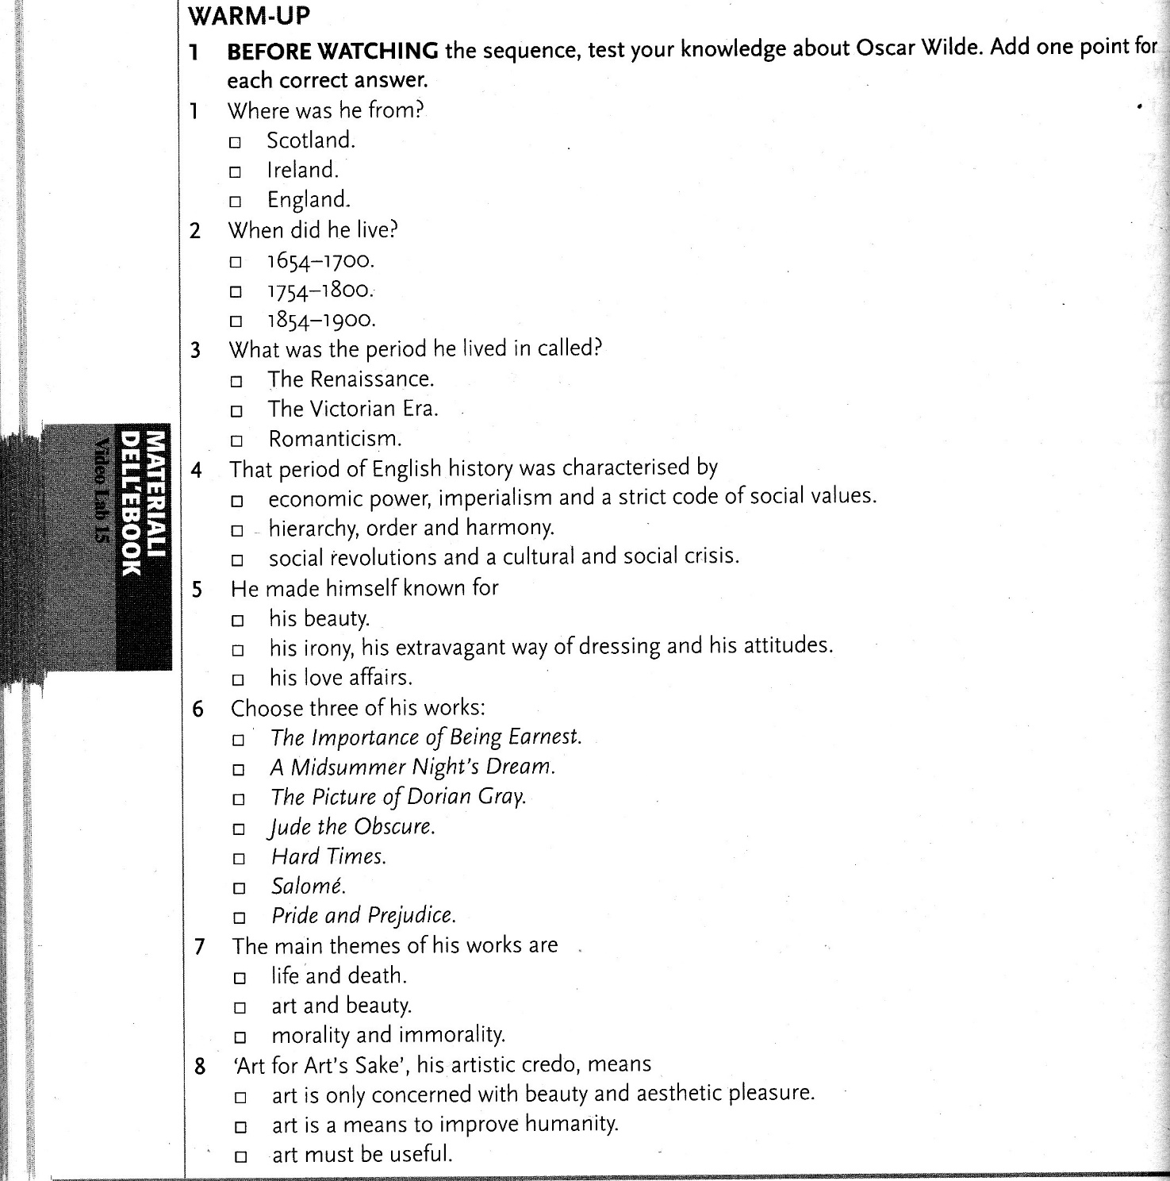

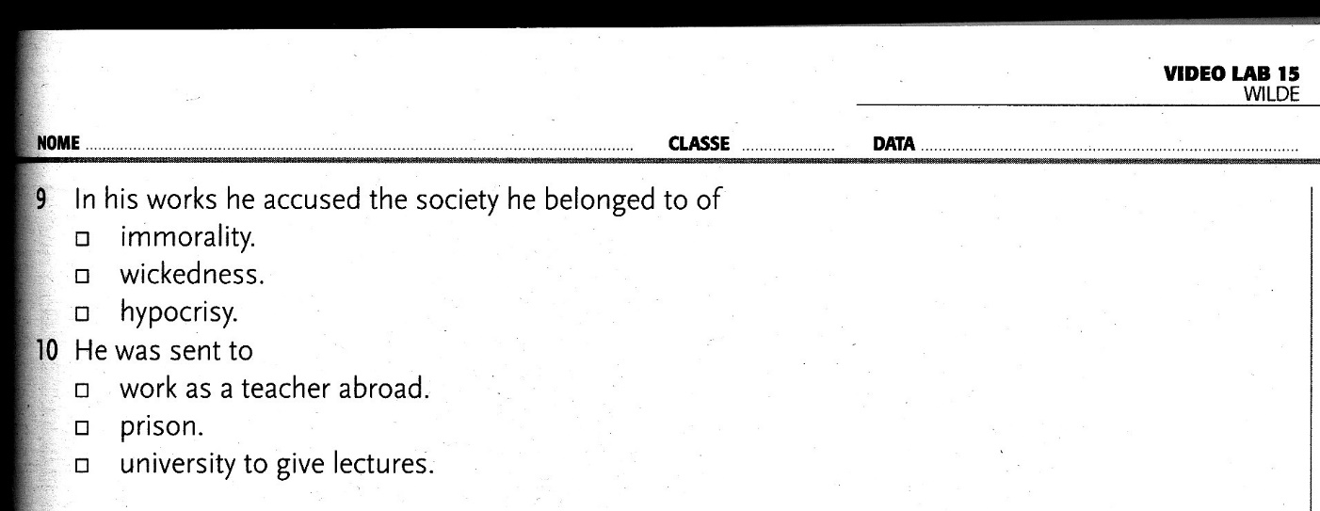

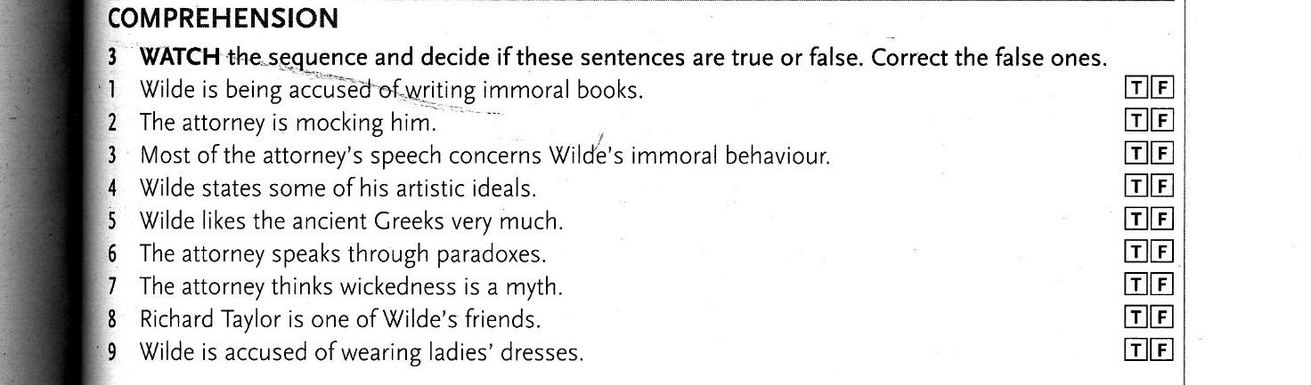

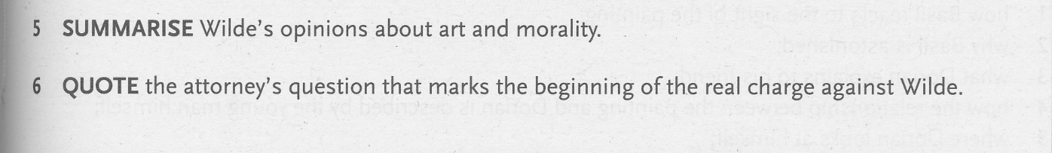

**THE PICTURE OF DORIAN GRAY: THE PACT**



