QUANTIFIERS 1: ESERCIZI
Exercise 1
CHOOSE the correct word or phrase to complete the paragraph.
In the past there weren’t (1) much / many food products to choose from. There were (2) a few / a little bread and (3) little / few vegetables. Only the very rich had (4) much / many choices. We are so lucky now – we have almost too (5) much / many things to choose to eat. How (6) many / much times do you eat a day? Not just meals, but all those (7) many / much snacks – or do you just have (8) a little / a few? Think while you’re eating your next full meal about how (9) many / much we have and how (10) little / few people had in the past.
Exercise 2
CHOOSE the correct word or phrase to complete the sentences.
1 Would you like a little / a few milk in your coffee?
2 She is upset because she received some / a bad news today.
3 We don’t have many / much gyms in our area.
4 Do you have many / much homework to do this evening?
5 Give him a / some water: he is sweating from working out so many / much.
6 A little / A few knowledge can be dangerous!
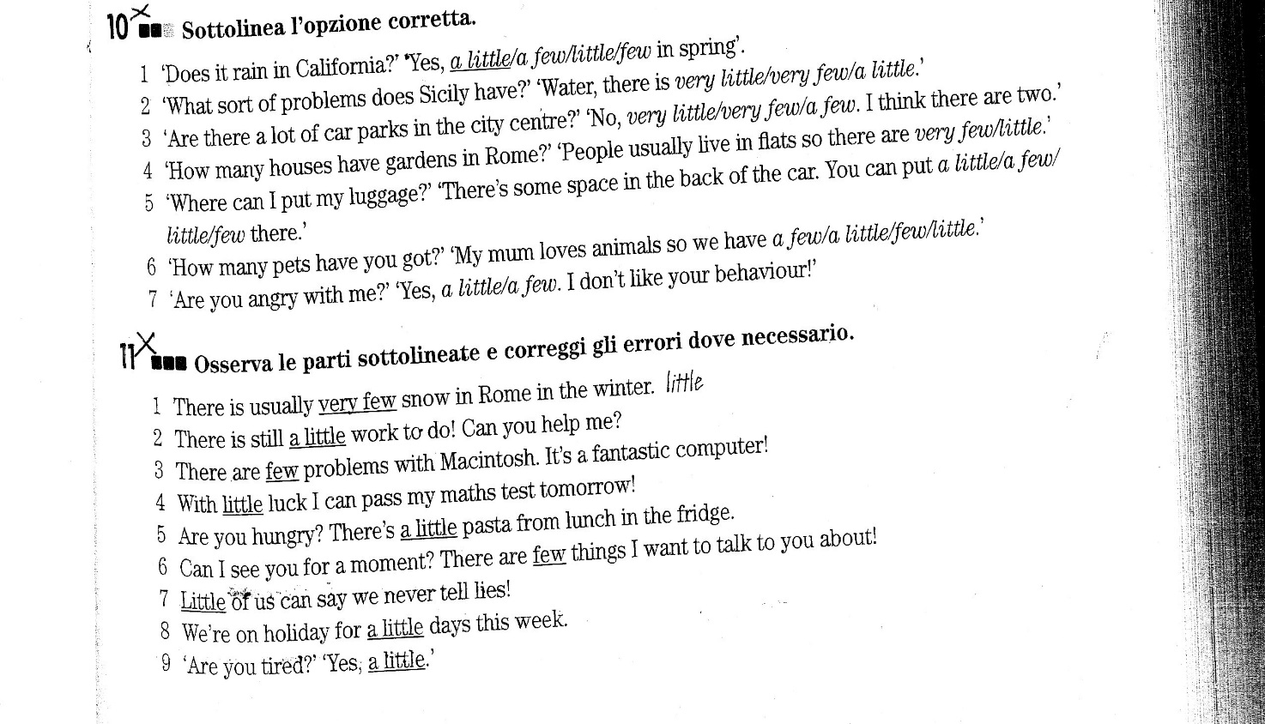
EXERCISE N.3
Complete the sentences with the correct option
1. He gets very / very much hungry when he watches his mum cooking
2. Hey Jane, we've little / a little flour, not enough for the recipe
3. There are few / a few ingredients on this list, are you sure it's ok?
4. There aren't much / many pastries at the bakery today
5. I don't fry very much / very, I prefer grilling food
6. We've got very much / a lot of fruit juice
7. We don't like eating in the canteen very / very much
8. Do your children eat very / very much for breakfast?
9. I like Steve a lot / many, he is very kind
10. I'm sorry I don't have much / many books on tennis
11. Your daughter is a very / much beautiful girl, you are very / much lucky
12. Spring is wonderful, there are much / a lot of flowers everywhere

EXERCISE N. 4
Complete the sentences with the correct option
1. There is so much / too many time before the interview, we can wait a few minutes
2. There are so many / so much wonderful cars here, I am amazed!
3. You buy too many / too much presents for people, you are too / too much generous
4. There are so many / so much places I'd like to visit in the world
5. I have so much / so to do for the wedding and so little / so few time to do it all
6. There are so many / too many passengers on the train that I can't find a free seat
7. Excuse me, madam, but your child is so / so many noisy! This is a restaurant after all!
8. You have so much / so many beautiful clothes, lucky you!
EXERCISE N. 5: Use much/many or a lot of . Write all the possible options
1. There aren’t ____________________ portraits of Shakespeare.
2. Don’t be discouraged! ____________________ people have failed to run the marathon.
3. How ____________________ pictures are you going to buy?
4. If you have ____________________ news call me back.
5. Last week there was so ____________________ rain that I was not able to go out.
6. Tom drinks ____________________ milk – one liter a day.
7. We didn’t take ____________________ photographs when we were on holiday.
8. Did you invite ____________________ guests?

EXERCISE N.6: Translate
1. Lei ha sempre tanti compiti di matematica
2. Quanto tempo hai adesso? Non molto, è molto tardi e devo andare a casa
3. Hai visitato molti paesi stranieri? No, solo un po'
4. Maria conosce poche persone e ha pochi amici perché è molto timida
5. Quanti fratelli hai?
6. Mia sorella mi da sempre molti consigli utili
7. Quando esci, compra un po' di latte e un po' di mele
8. Puoi darmi qualche informazione su questa città? Non conosco questa città molto bene, non abito qui

